SANJANA ASRANI

DIVISION: D7B

ROLL NO. 01

DLCOA EXPERIMENT 2 - IMPLEMENTATION OF HALF ADDER AND FULL ADDER USING LOGIC GATES:

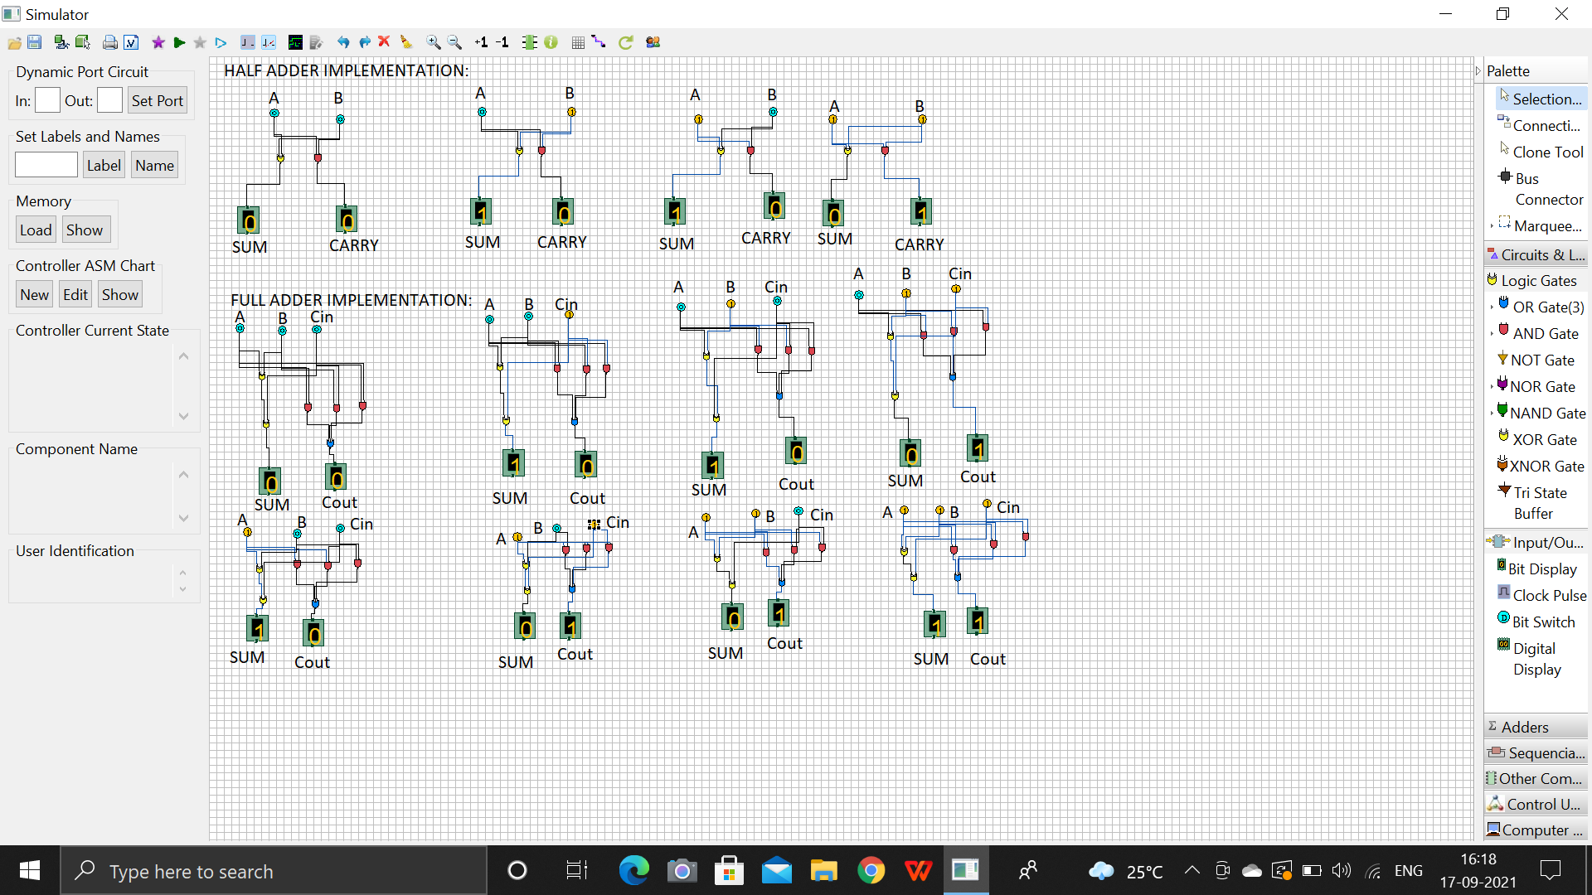

SANJANA ASRANI

DIVISION: D7B

ROLL NO. 01

HALF ADDER:

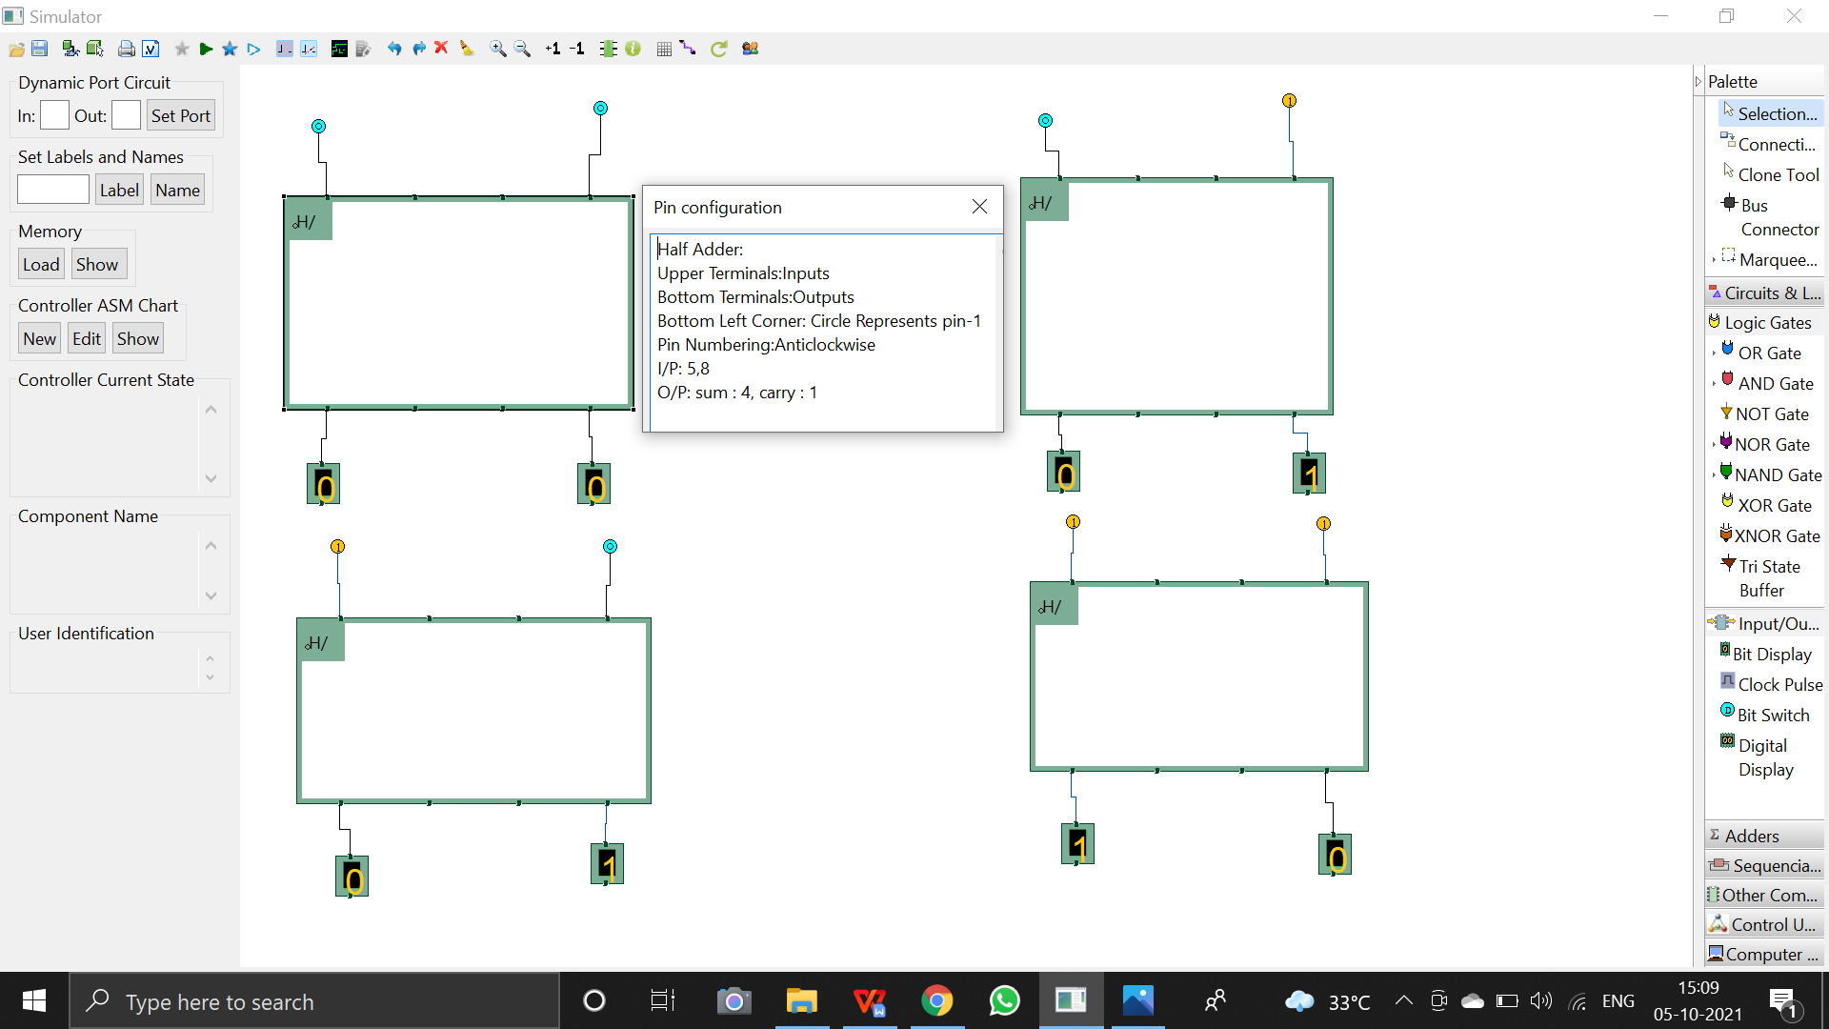

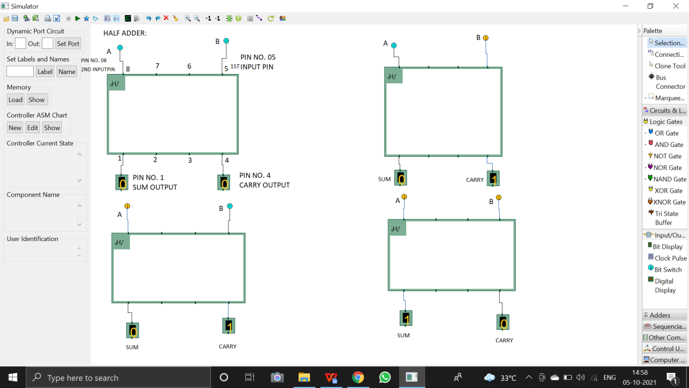

SANJANA ASRANI

DIVISION: D7B

ROLL NO. 01

FULL ADDER:

